Desiree Fryer, LCSW
Iron Ridge Counseling
ironridgecounseling@gmail.com • 435.600.1860
Dear Parents,
I wanted to reach out and introduce myself as a therapist option for your teen at Mountain Springs. I know how much thought and care goes into choosing the right person to support your child, and I'd love the chance to be considered.
Mountain Springs actually holds a special place in my own story. I spent nearly a decade there myself, working closely with students and staff and helping the program run well day to day. That time gave me a real, firsthand understanding of what teens at Mountain Springs experience; the structure, the challenges, and the growth that happens there. It's part of what led me to go back to school and become a therapist in the first place.
Today I hold a Master of Social Work from the University of Utah and am a Licensed Clinical Social Worker, working as a Therapist at Moonridge Academy. I've continued working with adolescents in residential and therapeutic settings, providing individual and family therapy, executive functioning coaching, and facilitating groups and psychoeducational sessions. I'm trained and experienced in Dialectical Behavioral Therapy (DBT), certified in Brainspotting (Phase I), and have completed training in Emotion-Focused Family Therapy and Structural Family Therapy, so I'm comfortable working with your teen individually as well as bringing your family into the process.
What I love most about this work is walking alongside teens as they build the skills and confidence to navigate hard things, while also supporting families through that same process. Having worked at Mountain Springs, I bring both professional training and a genuine, personal familiarity with the environment your teen is in right now.
If you'd like to talk further about whether I might be a good fit for your teen, I'd love to connect. Please don't hesitate to call or email. I'm happy to answer questions or simply introduce myself further.
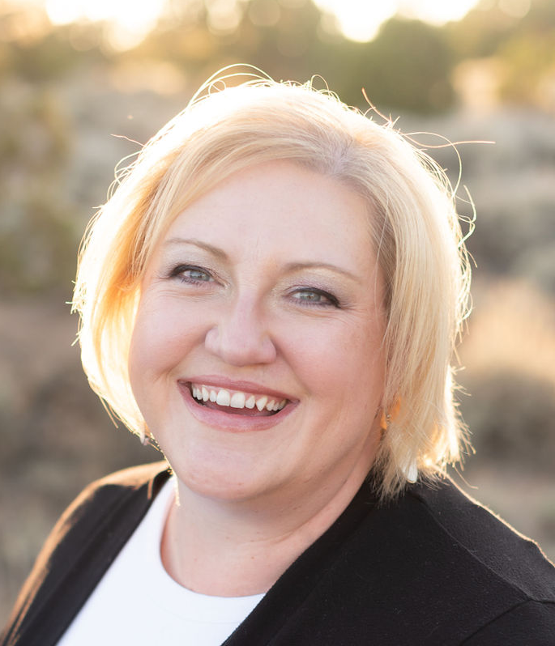
Thank you for your time and consideration.
Warmly,

Desiree Fryer, LCSW
Therapist, Iron Ridge Counseling
Desiree Fryer, LCSW
Therapist, Iron Ridge Counseling
ironridgecounseling@gmail.com • 435.600-1860

Education

High School Diploma, 2001
Cedar High School, Cedar City, UT
Bachelor of Science, Psychology, 2006
Southern Utah University, Cedar City, UT

Master of Social Work, 2024 University of Utah, Salt Lake City, UT

Professional Experience
Therapist 2024-Current
Moonridge Academy, Cedar City, UT
- Attended weekly treatment team and clinical meetings to support student treatment planning.
- Facilitated and co-led therapeutic and psychoeducational group sessions.
- Provided individual therapy and executive functioning coaching to students.
- Assisted with program projects and administrative tasks as needed.
- Completed accurate and timely clinical documentation for each student.
- Collaborated with staff and families to support student progress and treatment goals.

Therapist Intern 2022-2024
Kolob Canyon RTC, New Harmony, UT
- Participated in weekly treatment team and clinical meetings.
- Led and co-facilitated group therapy sessions.
- Provided individual therapy and executive functioning coaching to students.
- Assisted with program projects and special assignments.
- Maintained accurate and timely clinical documentation.

Admissions Assistant 2014-2022
CERTS Group, Cedar City, UT
- Create and manage all paperwork for all incoming students for 5 residential schools
- Work with marketing and admissions team to create and help carry out various projects
- Create, manage, and distribute company marketing material
- Assure SEVIS compliance for schools, enroll students, meet with representative for training
- Organize marketing trips for educational consultants (itineraries, travel arrangements, etc.)

Director of Operations 2007-2014
Mountain Springs Preparatory Academy, Cedar City, UT
- Managed business finances, including accounts payable, accounts receivable, billing, and expense reporting.
- Coordinated with contractors to oversee facility maintenance, repairs, and improvement projects.
- Collaborated with the management team to support organizational goals and daily operations.
- Mentored students and provided support in achieving personal and academic goals.
- Planned and coordinated educational travel experiences for staff and students, including domestic and international treks.

Staff Director and Team Leader 2005-2007
Mountain Springs Preparatory Academy, Cedar City, UT
- Supervised staff during shifts to ensure smooth operations and compliance
- Managed HR functions including hiring, training, performance management, and terminations
- Promoted a structured, accountable, and team-oriented work environment
- Ensured compliance with organizational policies, procedures, and safety standards

Youth Mentor 2004-2006
Moonridge Academy, Cedar City, UT
- Collaborated with therapists and team members to support clients in their treatment goals, and maintain a safe, supportive environment.
- Fill out required documentation daily to monitor client progress.
- Ensured student safety through consistent supervision and support.
- Assisted students with daily living and self-care skills.
- Facilitated recreational, educational, and therapeutic activities.

Camp Counselor 2003
Camp Friendship, Palmyra, VA
- Collaborated with fellow counselors to plan and implement daily programming.
- Managed cabin responsibilities, and camper accountability, behavior support, and daily routines.
- Encouraged participation and teamwork through outdoor adventures, games, and special events.

Paraeducator, Cross Hollows Intermediate School, Cedar City, UT 2001-2003
- Supported students with severe special needs in academic, behavioral, and daily living activities.
- Assisted with implementing IEPs and classroom instruction.
- Provided one-on-one and small-group academic and behavioral support.
- Fostered a safe, structured, and inclusive learning environment.

Trainings, Certifications, and other skills | Trained and experienced in Dialectic Behavioral Therapy (DBT)  Certified in Brainspotting (Phase I)  Completed training in Emotion-Focused Family Therapy and Structural Family Therapy.  Comfortable and knowledgeable in Group, Individual, and Family Therapy.

